Software Requirements Specification for
<Fleets>
Version 1.0 approved
Prepared by <Jovan Stojanovic>
<ZESIUM>
<02.08.2018>
Table of Contents
1. Introduction 1
1.1 Purpose 1
1.2 Document Conventions 1
1.3 Intended Audience and Reading Suggestions 1
1.4 Product Scope 1
1.5 References 1
2. Overall Description 1
2.1 Product Perspective 1
2.2 Product Functions 2
2.3 User Classes and Characteristics 3
2.4 Operating Environment 3
2.5 Design and Implementation Constraints 3
2.6 User Documentation 4
2.7 Assumptions and Dependencies 4
3. External Interface Requirements 4
3.1 User Interfaces 4
3.2 Software Interfaces 4
3.3 Communications Interfaces 5
4. Mobile app Features 5
4.2 Log in 6
5. Other Nonfunctional Requirements 10
5.1 Performance Requirements 10
5.2 Safety/Security Requirements 10
5.3 Software Quality Attributes 10

Revision History
Name | Date | Reason For Changes | Version
Jovan Stojanovic | 02.08.2018 | Initial version | V1.0

Introduction

Purpose
Fleets is the system with goal of optimizing transport of building materials. Fleets purpose is to speed up the communication between different stakeholders in chain of trading of materials and transporting them. Fleets would like to automatize process of buying and ordering building materials where all stakeholders in the chain will have their own interface which will allow them to track process, to make a specific action and to communicate to each other.

Document Conventions
All features listed in this SRS will be focus on implementation of MVP solution and all of them will be characterized as priority ones.

Intended Audience and Reading Suggestions
SRS will cover different domains where listed roles will have their domain parts and it will be able to find all necessary details for the efficient execution of this system.
:
- Developers
- Project manager
- Designer
- User
- Tester

Product Scope
Fleets is Uber like system for optimization of building material in transportation. Goal is to speed up communication between parties in that chain, to bring transparency to the process and to make a bigger ROI for all parties in the chain by being more organized and faster daily. Goal of the Fleets is to bridge Clients, Fleets, Driver companies, Drivers, Material supplier companies.

References
- Link to Jira project
- Link to Design
- Link to test cases
- Link to examples

Overall Description

Product Perspective
Fleets mimic functionalities of Uber application with focus on truck transportation. In system it will be several pod systems and roles:
- Clients
- Fleets
- Truck companies
- Material suppliers

  - Clients - User will have an option to registration on the system and to log in on web or mobile app. Clients will have a form where they will make an inquiry about their need. Clients will have option of paying to the Fleets for the goods and transportation that comes through this channel. Client User will have option of previewing their history of actions.
  - Fleets -There will be two types of roles of Fleets Users (Manager and Chief Admin). Fleets will have two interfaces, mobile and web. Main goal of Fleets is distribution of inquiries, organization of transportation and payment. Chief admin user will have a chance to preview all actions and results with his separate dashboard.
  - Transportation companies – There will be three types of User (Dispatcher, Truck driver and Chief Admin). Dispatcher User will have an option to administrate his Fleet, to add details about availability of his company and drivers. He will be responsible of micromanagement of the transportation process by adding details on his Fleet web app. Truck driver is second role, they will be responsible for direct transportation. Truck drivers will have their own mobile app where they will be getting Inquires via push notifications. Drivers will be able to respond on a inquiry or to cancel it. They will have option to apply for the tour and in that case their drive will be monitored by Client, Dispatcher and Fleets manager. Truck driver will be guided by Fleets to his Loading station. On Loading station, he will be asked for the identification which will be done by insertation of Fleet generated code.
  - Material suppliers- this type of Users will have two roles ( Chief admin and Manager). Manager will be assigned for micromanagement of one individual transportation (payment, administration of data, alerting etc). Chief admin will have a chance to monitor info about payment, to edit invoicing, to track his subscription model to Fleets. These functionalities will be postponed for Second phase.

Product Functions

Major functions of the systems are:

- Database development
- Model development
- Webservice and API development
- Android and iOS mobile native development
- Web apps for User, Fleet, Transportation company and Material supplier

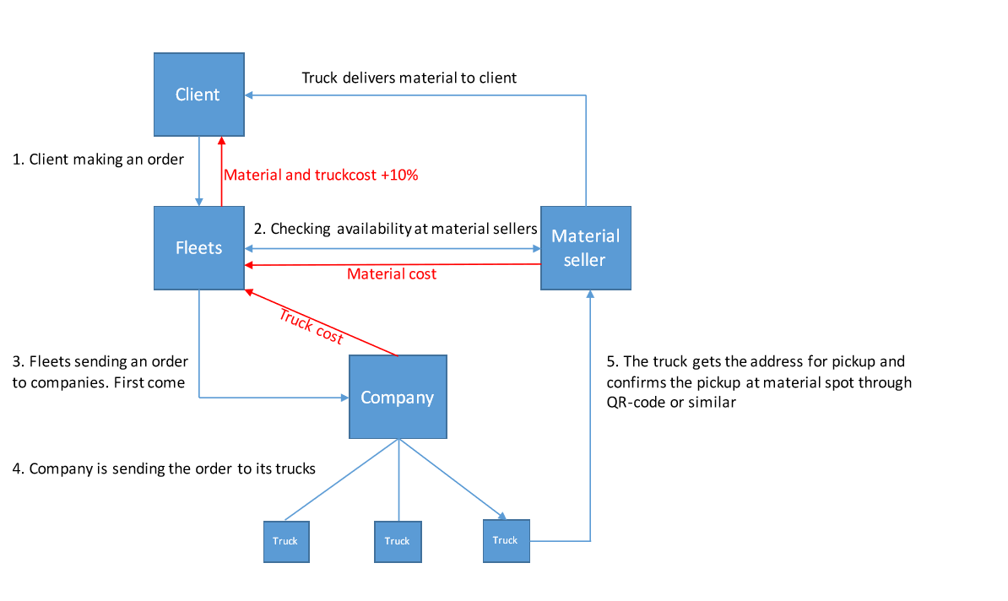

User Classes and Characteristics
User roles:

Client- Basic User - permission to log on Fleets web and mobile app
Fleets-Manager permission to log in to Manager Fleets web and mobile app
Chief admin-Permission to log in to Fleets web and mobile app and CMS where dashboard is displayed.

Transportation company – Dispatcher - permission to log in Web app
Truck driver-permission to log in only on mobile app
Chief Admin – permission to log in on web and mobile plus Transportation company CMS
Material Seller – Manager- he will have a permission to log in mobile app and web app

Operating Environment
- Web apps need to work on following browsers: Opera, Chrome, Safari, Mozilla Firefox
- Mobile apps- work for Android and iOS platform

Design and Implementation Constraints
Main constraint is UX that will be followed for truck driver because that part needs to be very user friendly and with less steps as it can.
Second concern is related to GPS location tracking of the User, it will power down user battery where that might be the issue because assumption is that those tours will be far away and that can affect user availability to answer on Inquires.
Application needs to work on Swedish and English

User Documentation
- Link to Jira project
- Link to Design folder
- Link to test plan
- Link to competitor example document

Assumptions and Dependencies

Assumptions

- For the first phase all features will be reduced to execution of MVP that needs to show process of communication
- Zesium will have daily basis support from the side of Fleets regarding project needs and consultation
- Google API will work properly for GPS location features
- There will no be complex payment model for initial phase
- There will no be some specific restriction regarding state policy, payment or other parts that can influence execution of the project
- Material seller features will be postponed for the next phase
- Material on seller’s storage will be always available and it will be able to cover all inquiries from the Clients
- There will not be complex analytic and dashboards for the First phase of the project that can affect right execution
- All agreed suggestions will be confirmed from the side of the Client and there will no be some big changes to it

Dependencies

- Testing from the side of client will be on a high level
- All suggestion and ideas need to be precisely communicated
- Google API will work on a high level
- Cloud infrastructure will work on a high level and it will be functional

External Interface Requirements

User Interfaces
Guide for UI will be added additionally. It will cover color standards, button standards, UX navigation architecture.

Software Interfaces
Main elements:
- Database: My Sql
- Backend development: JavaSpring
- Android mobile: Android Studio
- Ios mobile: Swift
- API documentation: Swagger
- Web services: Restful JSON format
- Map service provider: Google Geolocation API
- Payment provider: Stripe
- Push notification-Firebase
- Other libraries: Needs to be added – Frontend libraries etc
- Protocols: Oauth

Communications Interfaces
Project management communication:
- Daily communication
Main channel of communication will be Skype group- Fleets development. In this group will be all necessary members who are assigned for the right execution of the project

- Official communication
Will be organized by emails

- Project management communication
For organization of the project it will be used JIRA. Jira will be organized according to SCRUM principles. Before start of the implementation it will be created precise Product backlog with all User stories etc. Each User story needs to be organized in a manner where will be possible to execute it in a one day( all bigger US will be marked as Epics and it will be divided to smaller chunks)

App communication interface:

- Protocol that will be used is HTTPS.
- Push notification it will be used Firebase
- Client-server communication it will be used standardize Restful JSON webservice format

Mobile app Features
Registration 4.1.

Registration- All users will be able to register on the system but with different permission roles, Oauth authentication of the User need to be implemented. All User will need to insert their details but for some roles that information will be different. For all registration forms need to be implemented Error handling where User will be notified that he didn’t insert right format of insert parameter.

4.1.1 Client User - This User role will need to insert following information:
- Name and Surname
- Email address
- Company
- Phone Number
- Password (needs to be implemented security check min 6 characters, 1 capitol letter and 1 number)
- Repeat password
- Note: this user will be able only to login into Client mobile and web app!

4.1.2 Fleets User -Will not have registration screen, all Users will be directly added to database where they will be able to log in.

4.1.3 Transportation company – Dispatcher - Will not have registration screen in MVP version, all Users will be directly added to database where they will be able to login

4.1.4 Material Seller – Manager- Will not have registration screen in MVP version, all Users will be directly added to database where they will be able to login

4.1.5 Other - After registration process, verification mail will be sent to the Client Users email that he inserted. His Account will be active only when they confirm and verify that email by clicking on Submit button. It needs to be developed service that will on click do verification of that account. It needs to be developed access token model that will do refreshing of User access. When User opens application and not using it for a specified time, app will go to background mode and after some period app will force logout because security reasons.

4.2 Log in
Login of the User - All users will be able to log in on the system but with different permission roles. All User will need to insert their details but for some roles that information will be different. For all log in forms need to be implemented Error handling where User will be notified that he didn’t insert right format of insert parameter.

4.1.1 Client User - This User role will need to insert following information:
- Email
- Password

4.1.2 Fleets User - This User role will need to insert following information
- Email
- Password

4.1.3 Transportation company – Dispatcher - This User role will need to insert following information
- Email
- Password

    - Material Seller – Manager- This User role will need to insert following information
- Email
- Password

    - Other - After login process, User will be landed on different screens:
Client User-to home Inquiry screen
Fleets User – to home List of Inquires
Transportation company- to Home -Dashboard of all ongoing and waiting tours with their status

Error handling feature will be implemented for all Users where check of credentials are they inserted properly needs to develop.

4.3 Client Home Screen – List of tours
After successful login Client User will be redirect to the Home screen. On this screen he will be able to preview a list of all his transports and to create a new one. List of transport will be endless list. List of transport will present information about:
- Title of tour
- Material
- Quantity of tour
- Status of the tour
- Price

4.3.1 Details of the tour
When User click on one tour from the list he will be redirected to the Detail of the tour screen where we will have sections:
- Map – showing route from material seller to Client location
- Drivers-list of all drivers, Name Surname, Company
- Quantity – in tons / kg
- Price – Euro and Swedish Crown

4.3.2 Create an Inquiry

User will be able to create an inquiry where he will insert details about his need. User will mark and insert details about:

- Type of building material
- Note to building material (dry, wet…)
- Quantity
- Location
When User click on Submit button he will be sent that Inquiry to Fleets where Fleets will send that to suitable group of drivers that can assist in that transportation. Every Inquiry will have their own status:
- In progress
- Blocked
- Done
- Waiting

Inquiry is in progress when Fleet succeed to manage and find all drivers for wanted tour where all drivers verified that they will go on that tour.

4.4 Notification list of Client

Client User will have option to preview all notifications that are sent to him. He will have option to preview notification for:
- Accepted tour
- Declined tour
- Tour offer
- Discount price for some specific material

All notification will be accessible from Navigation drawer, where User will have a List of all notification chronologically sorted from newest to oldest.

4.5 Client Map

Client will have option to truck movement of trucks in Realtime from moment when they start the tour to moment of discharge of material on Clients location. Tracking will be visible on map as pin, if that tour needs more trucks information about their location will be presented for all of them. If GPS signal is lost, last known location will be presented on the screen.

  - Client User profile

User will have a option to change his profile info. He will be able to upload his avatar image and to preview his Thumbnail. User will be able to upload only one image. User will be able to change his password and to edit his information, everything except email address.

4.7 Navigation Drawer
Main component for User navigation will be Drawer. In drawer will be all main screens:
- Home
- Profile
- Log out
- About

  - Transport driver app
This application would be focused on mobile (android and Ios). Goal of this app is to help in transparency of communication, better/faster communication process where in the end driver will be able to earn more

    - Log in of driver
Transport driver app will have features of log in as described above.

    - List of driver tours
User will have option to preview all his tours that we drove. All drives are listed chronologically from newest to oldest. Drives will have information about end and last location, price, date and time. Each drive will have status of it ( done, blocked, in progress)

    - Detail of the driver tour
When User click on one tour from the list he will be redirected to the Detail of the tour screen where we will have sections:
- Map – showing route from material seller to Client location
- Time duration of time
- Quantity – in tons / kg
- Price – Euro and Swedish Crown

    - Driver Profile
User will have a option to change his profile info. He will be able to upload his avatar image and to preview his Thumbnail. User will be able to upload only one image. User will be able to change his password and to edit his information, everything except email address and company belonging.

4.8.5 Driver Payments
On this screen Driver will have list of all payments that he had in the past which needs to be chronologically sorted. User will be able to preview info:
- Who pay to him
- Date and time of payment
- Amount of payment

5. Web app features

5.1 Client -This User will have all features on web as he has on mobile platform.

5.2 Fleets-Manager and Chief Admin will have a option to log in on Web app. They will be able to login with their credentials:
- Email
- Password
Error handling would be implemented.

5.2.1 Fleets Home Screen - Fleets Manager and Chief admin will have a chance to monitor all Inquires and Drives in the system. All inquires will be listed chronologically where will be presented information:
- Client User name/surname
- Description of the tour
- Location
- Status
- Driver thread

Users will be able to preview also list of Drives that are in process. Users will see information:
- Client name
- Type of material
- Location from – to
- Driver Name/Names

5.2.2 Detail of inquiry
When Fleets Manager and Chief admin click on one inquiry he will be able to preview all details of it. He will be able to send notification to the client where he will have a form for text. That message will be sent via Firebase directly to the app of Client that is assigned for that inquiry. User will be able to chage status of that Inquiry by changing label. Users will be able to Report or Block that inquiry where in that case Client will be notified about that action.

5.2.3 Details of Drives
When Fleets Manager and Chief admin click on Drives he will be able to preview all details of it. He will be able to send notification to the Driver where he will have a form for text. That message will be sent via Firebase directly to the app of Driver that is assigned for that inquiry (he can send to all Drivers that are assigned). Users will be able to change status of that Drive by changing label. Users will be able to Report or Block that Drive where in that case Client will be notified about that action.

5.2.4 User profile
All Users of Fleet webpage will have their own profile where they would be able to change basic information:
- Name Surname
- Description
- Profile photo
- Password

5.2.5 Invoices and Payment
Chief admin User will have option to preview on web page section Invoices and Payment. He will be able to preview all payments/transactions that he had. All done payments will be listed chronologically where it will be presented information:

- Company Client
- Sum for payment
- Date and time of transaction
- Status of the payment (done, blocked, waiting)

Payment needs to be divided into three sections:
- Client invoices
- Material supplier payments
- Driver company payments

User will be able to delete transaction.
User will be able to initiate payment to the Driver company and Material supplier. Stripe service will be used for payment activities. Automatic logic of payment needs to be discussed.

Other Nonfunctional Requirements

Performance Requirements
Performance of notification system for all roles needs to be in real time without any delay.
Payment distribution needs to be precise and controlled.

Safety/Security Requirements
All safety requirements are separated and mainly focused on
- Security of User authorization
- Permission of roles and right distribution
- Payment process and transaction notification

5.3 Software Quality Attributes
Some to consider are:
- Availability -System needs to be up and running 24/7
- Flexibility -
- Interoperability-
- Maintainability – code and architecture need to be wrote to help in future easy maintenance process
- Reliability – all system functions need to work properly to suit business needs
- Reusability – code and architecture of the software need to be wrote in way that is reusable
- Testability – software needs to be testiable which means that Unity and Automatic test could be covered for that feature in the future
- Usability- Software needs to be write to satisfy User needs with goal of creating easy, efficient and effective User experience. Testing will be organized based on Usability testing that will be part of the test plan.

Other requirements

Testing-test plan needs to be prepared and developed before start of the development and it will be part of this SRS as Appendix. Test plan need to cover also Automatic tests that will be organized for features of:
- Transactions
- Notifications
- Log in and registration process
- Creation of inquiry
- Confirmation of tour (drivers)

